SIMATS ENGINEERING
ASSESSMENT TOOL 2: Scenario-Based Research Assessment
COURSE NAME: ARTIFICIAL INTELLIGENCE AND EXPERT SYSTEMS
COURSE CODE: MLA01
COURSE OUTCOME COVERED
CO1: Apply search algorithms and heuristic techniques to solve state-space search and optimization problems. (BTL 3)
Assessment Tool Weightage: 45 %
Total Marks: 50 Time: 60 Mins
No. of Questions: 5
Annexure A
Scenario-Based Research Assessment
Code of Conduct:
I _M.Raja Manohar Reddy / 192325062_ (Name / Reg No) certify that this submission is my
original work and that I have adhered to the guidelines specified for this assessment.
I understand that any violation of academic integrity rules will result in disciplinary
action.
Signature of the student:M. Raja Manohar Reddy
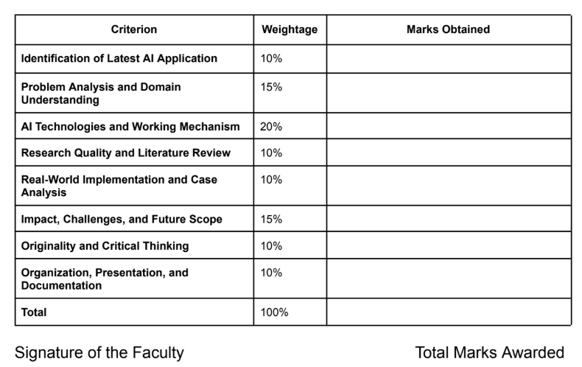

AI-Assisted Medical Imaging: Foundation-Model Radiology Triage
Domain: Healthcare
1. Title of AI Application
Aidoc CARE (Clinical AI Reasoning Engine) – an FDA-cleared foundation-model AI system that analyzes CT, X-ray, and other radiology scans to automatically triage and flag acute, life-threatening findings, selected as the AI application for the Healthcare domain.
2. Domain Selection
Healthcare – specifically AI-assisted medical diagnosis through radiology imaging.
3. Introduction and Background
Medical imaging – CT, MRI, X-ray, and ultrasound – is the single largest category of FDA-cleared AI in medicine. As of early 2026 the FDA has cleared over 1,500 AI-enabled medical devices in total, and radiology accounts for roughly three-quarters of them. Most of these tools are narrow, detecting a single finding such as intracranial haemorrhage or pulmonary embolism. Aidoc's CARE model, cleared by the FDA in January 2026, is significant because it is the industry's first foundation-model-powered clinical AI device: a single system that triages 14 acute abdominal conditions (11 newly cleared indications plus 3 previously cleared ones) from one CT scan in one workflow, instead of requiring a separate narrow tool for each finding.
Aidoc's broader platform, aiOS, is already deployed across nearly 2,000 hospitals worldwide and has analyzed more than 100 million patient scans, making it one of the most widely used clinical AI systems in production. In June 2026 the company also received FDA Breakthrough Device Designation for First Read, an extension of the same CARE model that drafts a preliminary radiology report directly from a chest X-ray. This combination – detection plus drafting – represents the current frontier of AI in diagnostic imaging.
4. Problem Identification
Radiology departments are seeing imaging demand grow faster than radiologist staffing. A Neiman Health Policy Institute study found that outpatient imaging interpretation turnaround times more than doubled between 2014 and 2023, with the steepest increases in the last two years. In busy emergency departments, scans are typically read in strict first-in-first-out order, which means a life-threatening finding on a scan ordered at 2 a.m. can sit unread behind a backlog of routine exams. CT-related delays alone can add up to 150 minutes to an emergency department patient's stay. The clinical risk is not a lack of imaging technology – it is that a human radiologist cannot instantly know which scan in a growing queue is the urgent one.
5. Need for AI Solution
A purely first-in-first-out worklist cannot prioritise by clinical urgency because urgency is not known until a radiologist actually opens and reads the scan. AI is needed here because it can pre-screen every scan the moment it is acquired, re-order the worklist so the most urgent cases surface first, and do this consistently across a hospital's entire imaging volume without adding staff. Earlier single-finding AI tools solved this for individual conditions but required deploying and maintaining a separate model for each one; a foundation model like CARE learns generalisable patterns across many conditions from one underlying architecture, which is what allows one deployment to cover 14 findings instead of one.
6. AI Technologies Used
Foundation models for clinical reasoning
CARE is described by Aidoc as a foundation model rather than a narrow, single-task classifier. Where earlier radiology AI trained one model per finding (one for haemorrhage, one for pulmonary embolism, and so on), a foundation model is trained on a much broader base of imaging and clinical data and can be adapted to recognise many related findings from shared underlying representations. This is what let Aidoc go from single-condition tools to 14 conditions cleared in a single 510(k) submission.
Convolutional and volumetric deep learning
Because a CT scan is a 3D volume of slices rather than a single 2D picture, the underlying detection models use 3D convolutional architectures that scan across neighbouring slices together, so a finding like a bowel obstruction is recognised from its shape across a volume, not from one slice in isolation.
Natural language generation for report drafting
Aidoc's First Read extends the same foundation model into text generation, converting detected imaging findings into a preliminary, human-readable draft report for the radiologist to review and finalise, rather than only producing a flag or a bounding box.
Workflow and integration software
The detection model alone is not enough to change clinical outcomes – it has to reach the radiologist before they open the scan. Aidoc's aiOS platform handles data normalisation across different scanner vendors, continuous performance monitoring, and integration with the hospital's existing PACS (picture archiving and communication system) worklist, so the AI's priority flag actually reorders what the radiologist sees next.
7. Working Mechanism
- A patient undergoes a CT (or X-ray) scan as part of routine or emergency care.
- The scanner's sensors acquire raw signal data and reconstruct it into a viewable image volume.
- The reconstructed scan is automatically and simultaneously sent to the CARE model alongside the radiologist's normal PACS worklist.
- The AI analyses the scan for the full set of 14 covered acute conditions in parallel, rather than one at a time.
- If a critical finding is detected, the case is flagged and moved to the top of the radiologist's worklist within minutes of acquisition.
- For chest X-rays, First Read additionally drafts a preliminary report describing the finding.
- The radiologist opens the prioritised case, reviews the AI flag and any drafted text against the actual images, and confirms, edits, or overrides it.
- The radiologist's finalised report is what becomes part of the patient's official medical record – the AI output is always a draft or a priority signal, never the final diagnosis.
8. Architecture
The pipeline runs from the physical scanner sensors through to a human-confirmed report: Image Reconstruction → Preprocessing → AI Inference → Triage & Prioritization → Radiologist Review → Report Generation.
[FIGURE: architecture pipeline diagram — the one shown inline in this chat earlier]
8.1 Image reconstruction
- Purpose: Convert raw sensor signals from the scanner into a viewable image or volume.
- Why it is needed: Sensors do not directly output pictures – a CT detector array outputs attenuation readings, and an MRI receive coil outputs an RF signal; both need dedicated reconstruction math before they are an image at all.
- Input: Raw detector signals (CT attenuation profiles, MRI k-space RF data, or X-ray flat-panel charge readings).
- Output: A reconstructed 2D image or 3D volume.
8.2 Preprocessing
- Purpose: Normalise and clean the reconstructed image before AI analysis.
- Why it is needed: Scans from different scanner manufacturers and protocols vary in resolution, contrast, and noise; the AI model needs a consistent input format to perform reliably across hospitals.
- Input: Raw reconstructed image/volume from any supported scanner vendor.
- Output: A normalised, denoised image in the model's expected format.
8.3 AI inference
- Purpose: Analyse the scan for the full set of covered acute findings.
- Why it is needed: This is the step that actually performs the clinical detection task the AI exists for – identifying patterns a human would otherwise have to search for manually.
- Input: Preprocessed image/volume.
- Output: A set of findings, each with a confidence score, plus (for First Read) draft report text.
8.4 Triage & prioritization
- Purpose: Convert AI findings into a re-ordered radiologist worklist.
- Why it is needed: A detected finding only helps the patient if it reaches a human faster than it otherwise would; this layer is what actually changes clinical workflow rather than just producing a label.
- Input: Findings and confidence scores from AI inference.
- Output: A re-ranked worklist inside the hospital's PACS system.
8.5 Radiologist review
- Purpose: A licensed radiologist reviews the prioritised case and the AI's findings against the real images.
- Why it is needed: AI outputs are not a diagnosis; regulatory clearance for tools like CARE and First Read requires a qualified human to confirm, edit, or reject every AI output before it affects patient care.
- Input: Prioritised case, AI findings/confidence, draft report text (if available).
- Output: A radiologist-confirmed or corrected set of findings.
8.6 Report generation
- Purpose: Produce the final clinical report that goes into the patient's record.
- Why it is needed: The referring physician and patient need one authoritative, human-signed document, not a raw AI output.
- Input: Radiologist-confirmed findings.
- Output: Finalised radiology report delivered to the treating physician.
9. Data Sources and Processing – How the Imaging Sensors Work
Every AI radiology model is only as good as the sensor data it is trained and run on. The four major imaging modalities use fundamentally different sensor physics, which is worth understanding before trusting any AI built on top of them.
Sensor comparison table:
Modality | Sensor technology | Physical principle | Key limitation
CT (computed tomography) | Scintillator + photodiode detector array (or direct-conversion semiconductor detectors) opposite a rotating X-ray tube | X-rays pass through tissue and are absorbed differently by bone, soft tissue, and air; the detector array measures attenuation from hundreds of angles per rotation, and reconstruction software converts these attenuation profiles into a cross-sectional image | Uses ionizing radiation; motion during the scan blurs the reconstruction
MRI (magnetic resonance imaging) | Superconducting magnet, gradient coils, and RF transmit/receive coils – no X-ray sensor at all | A strong static magnetic field aligns hydrogen protons in the body; gradient coils vary the field spatially to encode position; an RF pulse briefly knocks the protons out of alignment, and the receive coil detects the signal as they relax back, which a Fourier transform turns into an image | No ionizing radiation, but scans are slow (many minutes) and the strong magnet is unsafe near ferromagnetic metal
Digital X-ray (radiography) | Flat-panel detector – amorphous silicon photodiode array behind a scintillator layer, or a direct-conversion amorphous selenium panel | A single X-ray pulse passes through the body and the flat panel directly converts the transmitted photons into an electronic charge map in one exposure, producing a 2D projection image | Only a 2D projection – overlapping structures can hide findings that a 3D scan (CT) would catch
Ultrasound | Piezoelectric transducer array | The same crystal elements that emit a high-frequency sound pulse also receive the echoes reflected at tissue boundaries; the system measures the time delay and echo strength of each return to build a real-time cross-sectional image | No radiation and real-time imaging, but image quality is highly operator-dependent and degrades through bone or air
CT (computed tomography)
Aidoc's CARE model, in its current FDA-cleared form, works on CT and X-ray data specifically. A CT scan is acquired by rotating an X-ray tube and an opposing detector array around the patient; the detector array is typically built from scintillator crystals (which convert incoming X-ray photons into visible light) coupled to photodiodes (which convert that light into an electrical signal), or increasingly from direct-conversion semiconductor detectors that skip the light-conversion step entirely for sharper signal. Hundreds of these attenuation readings are captured per rotation, from many angles, and a reconstruction algorithm (filtered back-projection or, more commonly today, iterative reconstruction) combines them into the cross-sectional slices that make up the 3D volume the AI actually analyses. This matters clinically because the detector's raw sensitivity and the reconstruction algorithm's noise handling both directly affect whether a small finding, such as an early appendicitis, is visible enough for the AI (and the radiologist) to detect at all.

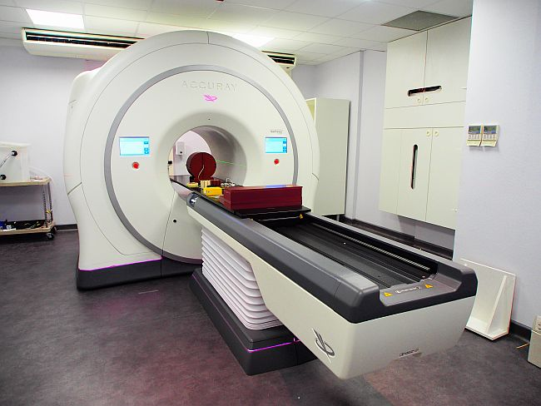

[FIGURE 1a: CT gantry schematic diagram — shown inline earlier]
Digital X-ray (radiography)
A conventional digital X-ray uses a single, brief exposure rather than a rotating gantry. The patient is positioned between the X-ray source and a flat-panel detector. In an indirect-conversion panel, a scintillator layer (commonly caesium iodide) absorbs the transmitted X-ray photons and re-emits them as visible light; a dense grid of photodiodes directly behind it converts that light into an electrical charge, pixel by pixel. Direct-conversion panels (using amorphous selenium) skip the light-conversion step and turn X-ray photons straight into charge, which gives sharper spatial resolution at the cost of a more specialised, more expensive detector. Either way, the readout electronics digitise the charge map from every pixel in the panel into the single 2D image a radiologist or an AI model like First Read then reads.

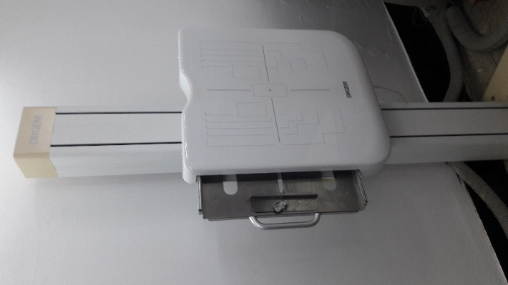
[FIGURE 2b: your DRGEM flat-panel detector photo]
MRI (magnetic resonance imaging)
MRI does not use X-ray sensors at all, which is why it involves no ionizing radiation. A large superconducting magnet creates a strong, constant magnetic field that aligns the spin of hydrogen protons throughout the patient's body. Gradient coils then layer a small, precisely varying field on top of the main field so that protons at different positions experience slightly different field strengths – this is what lets the system encode spatial position into the signal. An RF (radio-frequency) coil briefly transmits a pulse that knocks the aligned protons out of equilibrium; as they relax back into alignment they emit a faint RF signal of their own, which the same or a separate RF receive coil detects. A Fourier transform converts this raw frequency-domain signal ("k-space" data) into the final image. Because the whole process depends on protons relaxing over time rather than a single instantaneous exposure, MRI scans take much longer than a CT or X-ray.

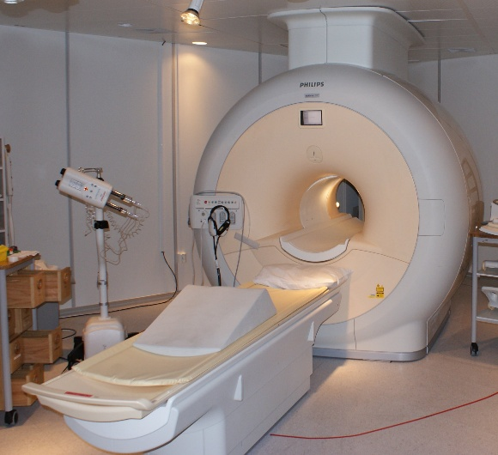

[FIGURE 3a: MRI cross-section schematic]
Ultrasound
Ultrasound is the only common imaging modality that is both radiation-free and truly real-time. A handheld probe contains an array of piezoelectric elements – crystals that convert an applied electrical pulse into a high-frequency sound wave, and, critically, can also do the reverse: convert an incoming sound wave back into an electrical signal. The same elements fire a short sound pulse into the body and then switch to listening, measuring the time delay and strength of echoes reflected wherever the sound wave crosses a boundary between two different tissue types (for example, muscle to fat, or a vessel wall). Because sound travels at a known, roughly constant speed through soft tissue, the time delay of each echo directly maps to depth, and the system rebuilds a live cross-sectional image many times per second.

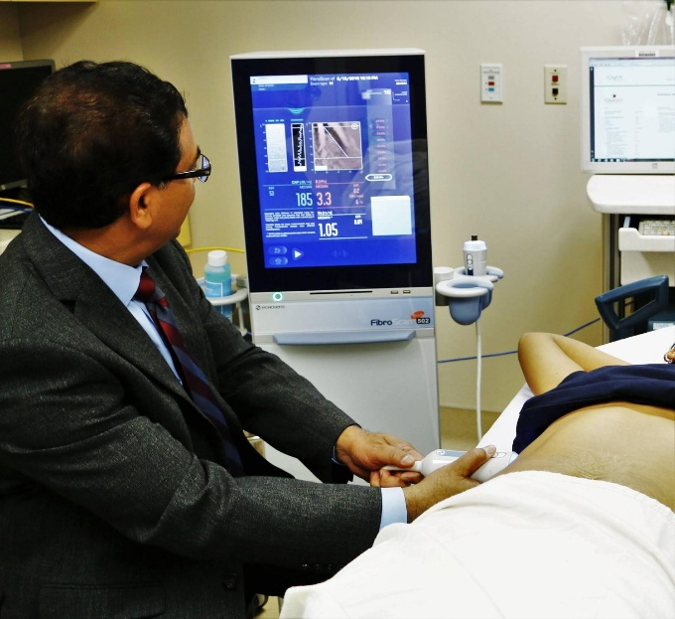

[FIGURE 4a: ultrasound transducer schematic]ch
10. Real-World Implementation
Aidoc's comprehensive abdomen CT triage tool was cleared by the FDA in January 2026, combining 11 newly cleared indications (including liver injury, spleen injury, bowel obstruction, and appendicitis) with 3 previously cleared ones into a single workflow. In FDA-reviewed pivotal testing, the newly cleared indications achieved a mean sensitivity of 97% (up to 98.5% in certain settings) and a mean specificity of 98% (up to 99.7%). The tool is delivered through aiOS, Aidoc's enterprise AI operating system, which is already running across close to 2,000 hospitals and has processed more than 100 million patient cases, making it one of the most widely deployed clinical AI platforms in the world. In June 2026, Aidoc received FDA Breakthrough Device Designation for First Read, which extends the same underlying CARE model to draft preliminary chest X-ray reports for four life-threatening findings.
Aidoc is one of several major players in this space rather than the only one. GE HealthCare currently holds the most FDA radiology AI authorizations overall (120, including acquired companies such as Bay Labs and Caption Health), followed by Siemens Healthineers (89), Philips (50), Canon Medical (45), and United Imaging (38), with Aidoc close behind at 31 authorizations as a standalone company. Other notable competitors include Viz.ai (stroke and cardiac triage), PathAI (pathology), and Tempus AI (multi-modal diagnostics). Radiology AI overall attracted a large share of the $10.7 billion in global health-AI venture funding raised in 2025.
11. Impact and Benefits
- Surfaces life-threatening findings earlier: 97–98% sensitivity/specificity on the newly cleared conditions means fewer missed urgent cases and fewer false alarms than older single-purpose tools
- Reduces effective wait time for urgent scans by re-ordering the radiologist worklist instead of leaving it strictly first-in-first-out
- Scales across an entire hospital's imaging volume without a proportional increase in radiologist headcount
- One foundation model covering 14 conditions is simpler for a hospital IT department to deploy and govern than 14 separate single-purpose tools
- Report-drafting tools like First Read return radiologist time to higher-value clinical judgement rather than routine transcription
12. Challenges and Limitations
- AI output is a draft or a priority flag only – a licensed radiologist must still confirm every finding, so the technology does not by itself solve a radiologist staffing shortage
- Model performance depends on image quality from the underlying sensor; a noisy scan, patient motion, or an unusual anatomy can reduce accuracy
- Currently cleared for a specific set of conditions on abdominal CT and chest X-ray – it does not yet generalise to every possible finding or every imaging modality
- Integration burden: hospitals must normalise data across different scanner vendors and connect the AI to their existing PACS, which is a real deployment cost even when the model itself works well
- Regulatory and liability questions remain about how responsibility is shared between the AI vendor, the hospital, and the radiologist when a finding is missed
- Novel imaging hardware in this space (for example, Midjourney's experimental whole-body ultrasound scanner, announced in mid-2026) illustrates that not everything generating impressive images is clinically validated – it has no FDA diagnostic clearance yet
13. Critical Analysis
Aidoc's CARE model is a genuine architectural shift, not just an incremental accuracy improvement: moving from one model per finding to one foundation model covering 14 findings addresses a real deployment problem (integration and alert fatigue), not just a detection-accuracy problem. That said, the sensitivity and specificity figures, while strong, are FDA pivotal-study numbers on a specific patient population and scan protocol; real-world performance across the full diversity of hospitals, scanners, and patients that aiOS now serves is worth watching as more post-market data accumulates.
It is also worth noting that radiology's dominance of FDA AI clearances (roughly three-quarters of all AI-enabled medical devices) is partly a reflection of which problems are easiest to validate – image-in, finding-out tasks have clear ground truth and well-established benchmarks – rather than radiology necessarily being the area of healthcare with the greatest clinical need. Comparing Aidoc's approach to GE HealthCare's larger but more fragmented portfolio of 120 separate authorizations suggests two competing philosophies: breadth-by-acquisition versus breadth-by-foundation-model, and it is not yet clear which will prove more maintainable at scale over the next few years.
14. Future Scope and Emerging Trends
Expansion to additional body parts and modalities
Aidoc has stated its next step is extending comprehensive triage to other body regions in CT and to X-ray, moving beyond the current abdominal CT focus toward a broader single-model coverage across a hospital's imaging volume.
Automated report drafting
First Read's chest X-ray report drafting is an early step toward AI producing a full draft radiology report across modalities, with the radiologist's role shifting further toward review and confirmation rather than first-pass interpretation.
Foundation models replacing single-task tools
As more vendors adopt the foundation-model approach that Aidoc pioneered for FDA clearance, hospitals should be able to consolidate many single-purpose AI tools into fewer, broader platforms, which reduces both cost and alert fatigue.
Reimbursement catching up to capability
Cardiac imaging AI already has dedicated CPT Category I reimbursement codes as of 2026; broader reimbursement pathways for triage and report-drafting AI are likely to follow as clinical evidence accumulates, which will materially affect how fast hospitals adopt these tools.
New sensor hardware
Experimental approaches such as large-array whole-body ultrasound scanning point toward imaging hardware that did not exist a few years ago; whether such hardware reaches the same level of FDA-cleared clinical validation as CT and MRI will determine whether it becomes a serious addition to the AI radiology pipeline or remains a research curiosity.
15. Conclusion
AI-assisted radiology, exemplified by Aidoc's CARE foundation model, shows how artificial intelligence can be layered onto existing, physically well-understood medical imaging sensors – CT detector arrays, MRI coils, X-ray flat panels – to solve a workflow problem that pure sensor hardware improvements cannot: getting the most urgent scan in front of a radiologist first. Because the underlying sensor physics differs so much between CT, MRI, X-ray, and ultrasound, the strengths and limits of the AI built on top of each are inherited directly from the sensor beneath it. The shift from narrow, single-finding tools to comprehensive foundation models marks a genuine architectural change in how clinical AI is built, and its continued expansion across body regions, modalities, and reimbursement pathways will determine how much of routine radiology triage becomes AI-assisted by the end of the decade.
16. References
[1] Aidoc, "Aidoc Secures FDA Clearance for Healthcare's First Comprehensive Foundation Model AI," PR Newswire, Jan. 21, 2026.
[2] K. Palmer, "FDA Clears Aidoc Tool to Detect 14 Different Conditions from a CT Scan," STAT News, Jan. 21, 2026.
[3] Becker's Hospital Review, "FDA Clears AI Triage Tool That Can Detect 14 Acute Conditions," Jan. 21, 2026.
[4] M. Larkin, "AI Model FDA-Cleared to Triage 14 Conditions," Medscape Medical News, Jan. 23, 2026.
[5] Diagnostic Imaging, "FDA Clears CT-Based AI Triage Platform from Aidoc," 2026.
[6] ITN Online, "FDA Grants Breakthrough Device Designation for AI That Drafts Radiology Reports," Jun. 25, 2026.
[7] OmniPACS, "FDA-Cleared AI Diagnostic Tools: What's Working in Radiology," May 2026.
[8] The Imaging Wire, "FDA Updates AI List with New Clearances," Mar. 2026.
[9] Pinggy, "AI Medical Imaging in 2026: Best Radiology AI Tools, FDA Clearances, and Diagnostic Accuracy," Jun. 2026.
[10] Radiology Business, "Radiology Gets 68 New FDA-Cleared Algorithms," Jun. 2026.
[11] IEEE Transactions on Medical Imaging, various issues, 2023–2026.

